**Task : Program to check the input number is Negative or Positive**

**Code:**

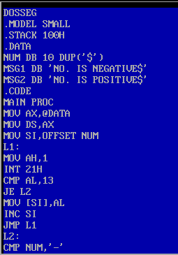

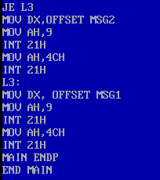

**Result:**

